Illustrations

1. Engraving of Foundling Hospital shortly after construction (1752)
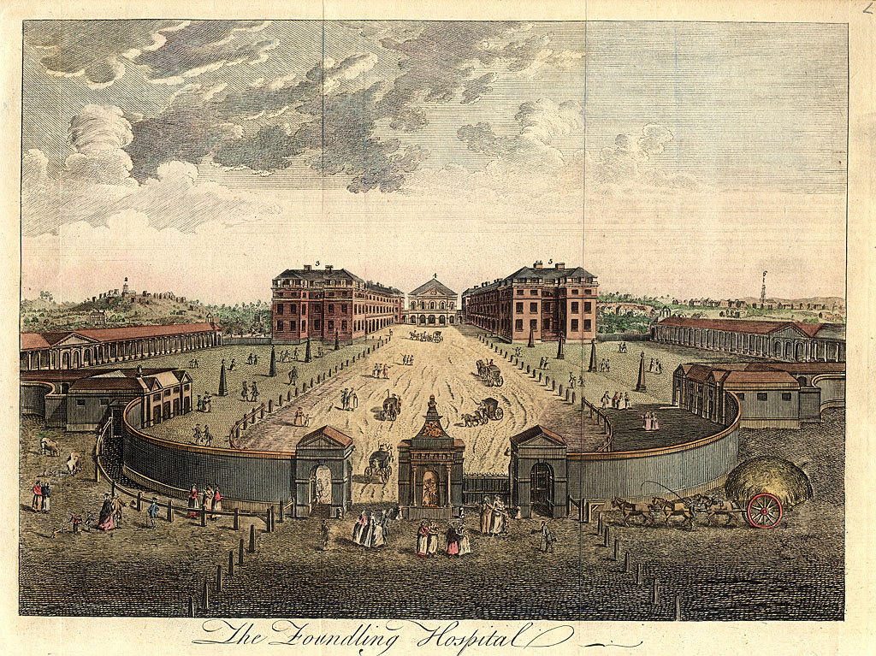

2. Foundling Hospital Engraving exterior circa 1850

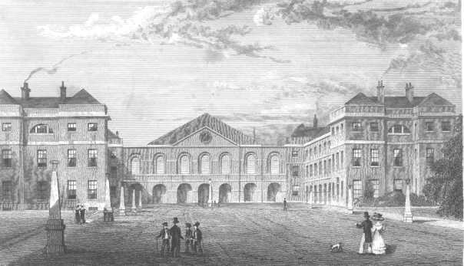
3. Interior of the Chapel of the Foundling Hospital

4. Ordnance Survey Map 1871 showing location of Foundling Hospital, between Brunswick Square and Mecklenburg Square

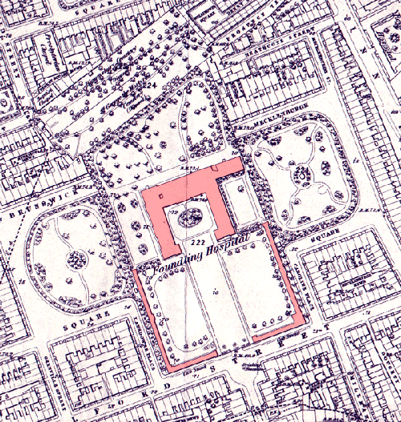

5. Last of two remaining buildings on Foundling Hospital site: 2005
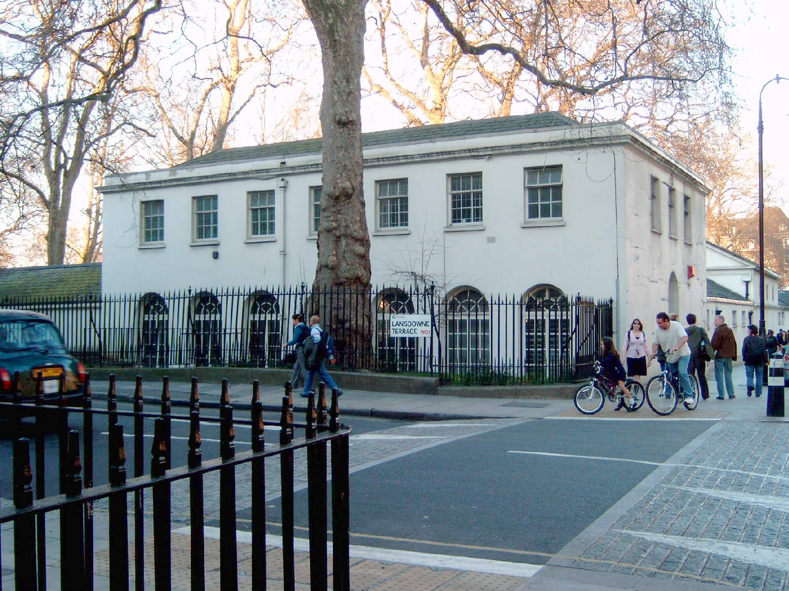

6. Sample of Mercier's handwriting, November 1869

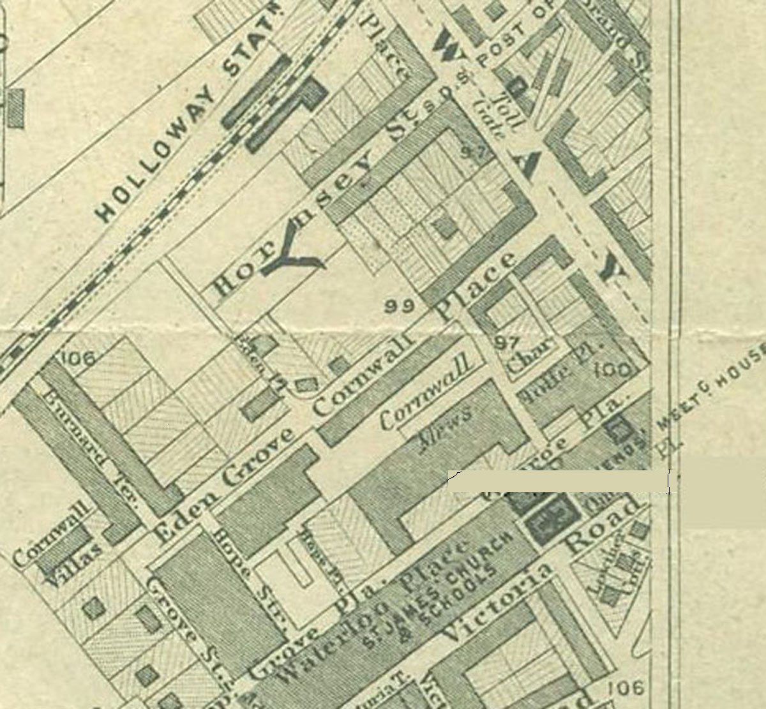
7. Extract from Stanford’s 1862 “Library Map of London”, scale 6” to the mile, showing Eden Grove where Lewis Mercier was living in 1871.

8. Volume of the "Minutes of the Select Commitees of the Foundling Hospital 1864-1886" including those relating to Mercier's dismissal as Chaplain.



