3 Bedroom in Carrboro, Utilities Included
1601 N. Greensboro St, Carrboro, NC 27510
Property Information |  |  |  | 
Bedroom(s) | 3 | Year Built | 1960
Bath(s) | 1 | Square Feet | 1,100
Neighborhood | Hunter Place | Garage | Carport
Elementary | Carrboro | Junior | McDougal
High School | Chapel Hill High
Rent: | $1,350 (utilities included) | Availability: | May '04
Lease Term: | At Least One Year | Application Fee: | - NA -
Contact: | Barbara Graham | 919-933-0650 | Barbara@allonebooks.com
Description: Brick home located on a convenient street. House has large back yard for gardening and enjoyment. Bus-stop at corner and easily accessible to town, UNC campus, and I-40. Bike path out front. New appliances and bath add updates to this solid ranch home. Less than a mile to Weaver Street and Carr Mill Mall, Carrboro Elem, and McDougal. Plenty of off-street parking.

Amenities: Washer & Dryer. Dishwasher. Refrigeration. Over-stove microwave. Patio. Fenced Backyard. Interior carpet and vinyl. Large kitchen with plenty of cabinets. Central A/C, Heat. Window blinds in all rooms. Back deck, front patio. Large fenced in yard.
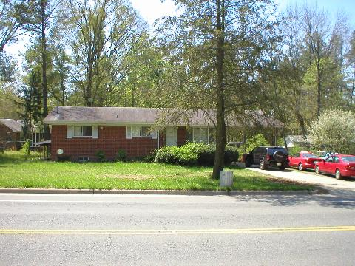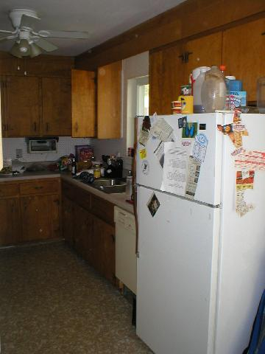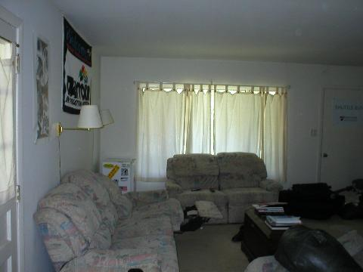

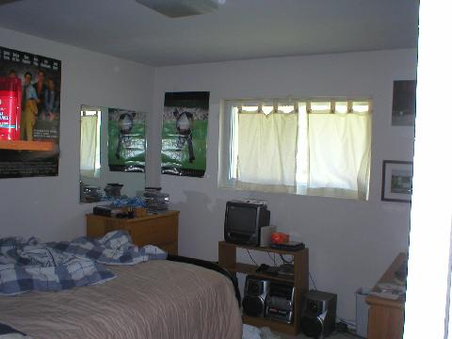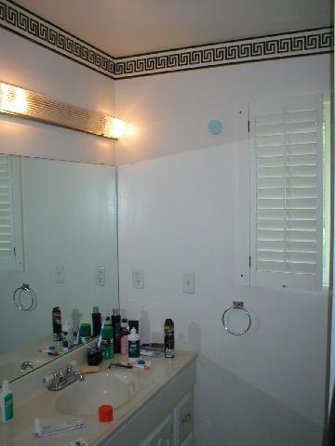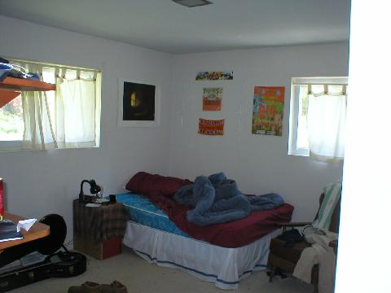

2 Bedroom in Carrboro, Furnished, Utilities Included
Short Term OK
Home Away from Home
1601 N. Greensboro St, Carrboro, NC 27510
Property Information
Bedroom(s) | 2 | Year Built | 1960
Bath(s) | 1 | Square Feet | 1,100
Neighborhood | Hunter Place | Garage | Carport
Elementary | Carrboro | Junior | McDougal
High School | Chapel Hill High
Rent: | $950 (utilities included) | Availability: | May '04
Lease Term: | Month to Month or Longer | Application Fee: | - NA -
Contact: | Barbara Graham | 919-933-0650 | Barbara@allonebooks.com
Description: Brick home located on a convenient street has a bright 2 bedroom apartment available May 1. Lots of windows, newly finished (1 year old). Bus-stop at corner and easily accessible to town, UNC campus, and I-40. Bike path out front. Less than a mile to Weaver Street and Carr Mill Mall, Carrboro Elem, and McDougal. Plenty of off-street parking. All furniture, power, water, & local phone included. Bikes available if needed. Short term rental (month to month) is OK. Non smokers, clean quiet dog considered. Fenced yard shared with upstairs. Furnished with queen and twin beds; includes sofas, desk, kitchen items, TV, dressers, etc. Just bring your clothes!

Amenities: Washer & Dryer (full size). Dishwasher. Refrigeration. Over-stove microwave. Ceramic-top oven. Fenced Backyard. Interior carpet and vinyl. Central A/C, Heat. Utilities included in rent (local phone, basic cable, power, water).
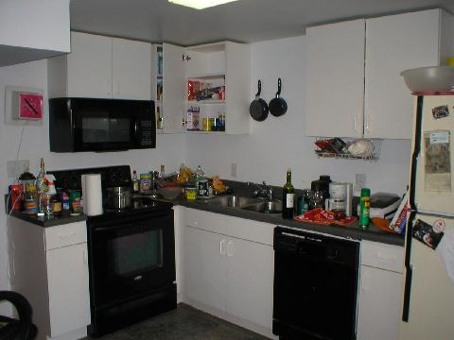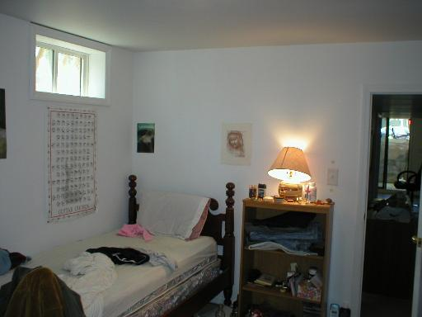

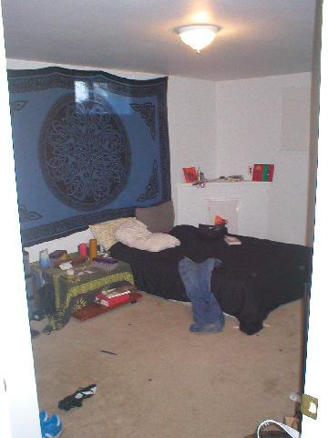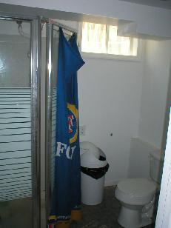

5 Bedroom House in Carrboro
1601 N. Greensboro St, Carrboro, NC 27510
Property Information
Bedroom(s) | 5 | Year Built | 1960
Bath(s) | 2 | Square Feet | 2,200
Neighborhood | Hunter Place | Garage | Carport
Elementary | Carrboro | Junior | McDougal
High School | Chapel Hill High
Rent: | $1,950 | Availability: | May '04
Lease Term: | At Least One Year | Application Fee: | - NA -
Contact: | Barbara Graham | 919-933-0650 | Barbara@allonebooks.com
Description: Brick home located on a convenient street. 3 bedrooms upstairs, 2 downstairs (not connected). 2 washer/dryers, 2 kitchens, 2 living rooms. House has large back yard for gardening and enjoyment. Bus-stop at corner and easily accessible to town, UNC campus, and I-40. Bike path out front. New appliances and bath add updates to this solid ranch home. Less than a mile to Weaver Street and Carr Mill Mall, Carrboro Elem, and McDougal. Plenty of off-street parking.

Amenities: Washer & Dryer. Dishwasher. Refrigeration. Over-stove microwave. Patio. Fenced Backyard. Interior carpet and vinyl. Large kitchen with plenty of cabinets. Central A/C, Heat. Window blinds in all rooms. Back deck, front patio. Large fenced in yard.

1 Bedroom Central Chapel Hill, Furnished, Utilities Included
Short Term OK
Home Away from Home
130 S Estes St, Chapel Hill, NC 27514
Property Information
Bedroom(s) | 1 | Year Built | 1967
Bath(s) | 1 | Square Feet | 712
Neighborhood | Camelot Village | Garage | Off-street Parking
Elementary | Glenwood | Junior | Grey Culbreth
High School | East Chapel Hill
Rent: | $750 (utilities included)  $695 4+ months  $595 12+ months | Availability: | now
Lease Term: | Month to Month or Longer | Application Fee: | - NA -
Contact: | Barbara Graham | 919-933-0650 | Barbara@allonebooks.com
Description: Comfortable, quiet, fully furnished 1-bedroom apartment available May 2004 for your home away from home. Located across from University Mall and just off Franklin St.

On bus lines F, G, or M (FG Saturdays, T/G weekday evenings). Buffered by trees and a stream, the apartment is across from stores, restaurants (including two of the best in Chapel Hill), banks, public library, and post office. Next to city park. About 720 sq. feet total in living room, bedroom, kitchen, bath. Camelot Village complex, built in 1967, has beautifully maintained grounds, lake, swimming pool, and clubhouse available for residents' use. Chapel Hill Community Center Park is right next door. From there the Battle Branch hiking trail leads to the UNC-CH campus (1.5 miles, walk or use included bike), while the Bolin Creek bikeway leads to Airport Road.

Rent $750/month, includes power, local phone, basic cable TV, and water/sewer. 4+ months is $695, and 12+ months $595. Security deposit is required. No smoking. Small dog is negotiable, with pet deposit.

Amenities: Washer & Dryer. Refrigeration. Over-stove microwave. Ceramic-top oven. Interior carpet and vinyl. A/C, Heat. Utilities included in rent (local phone, basic cable, power, water). 5 closets, and a shared balcony. Tastefully furnished with everything you will need for a comfortable stay:
-sofas, chairs
-desk
-armoire with TV and VCR, 2nd TV in bedroom
-king or two twin beds
-dressers, side tables
-bikes
-plants
-fully equipped kitchen with toaster, toaster over, food processor, coffee maker, china, glass glasses, Sabatier cutlery, cooking and baking supplies.

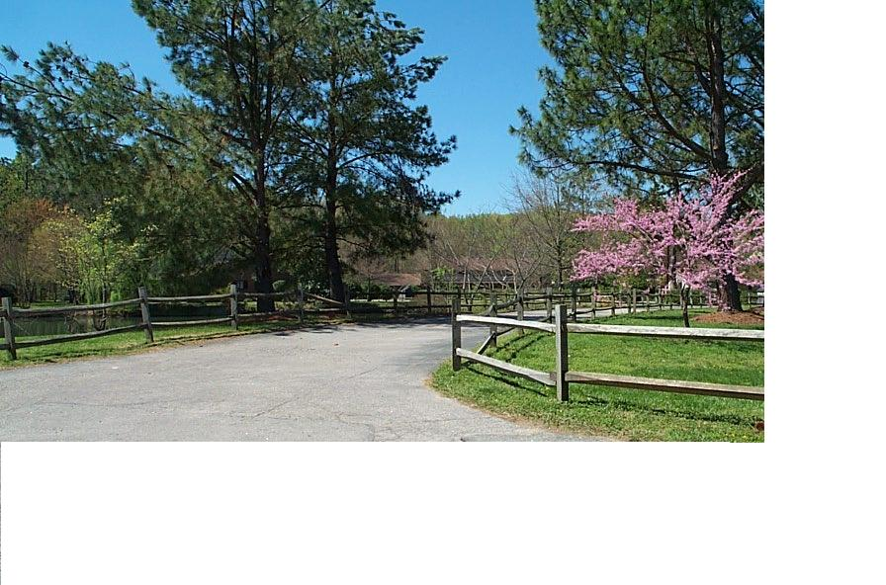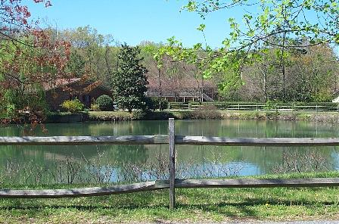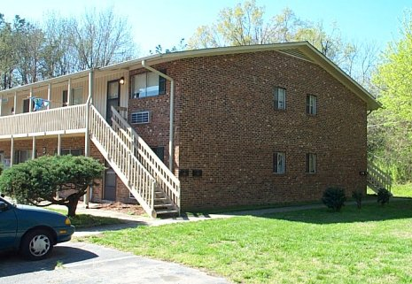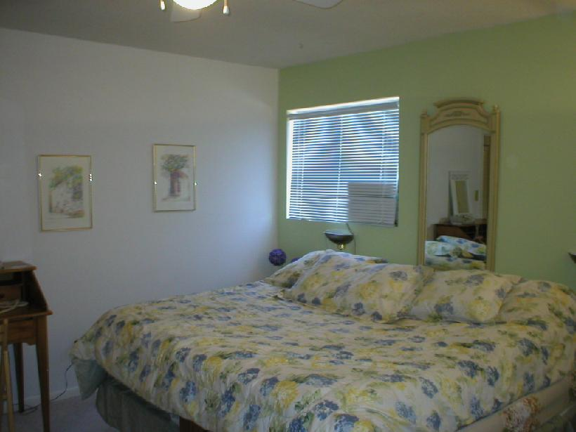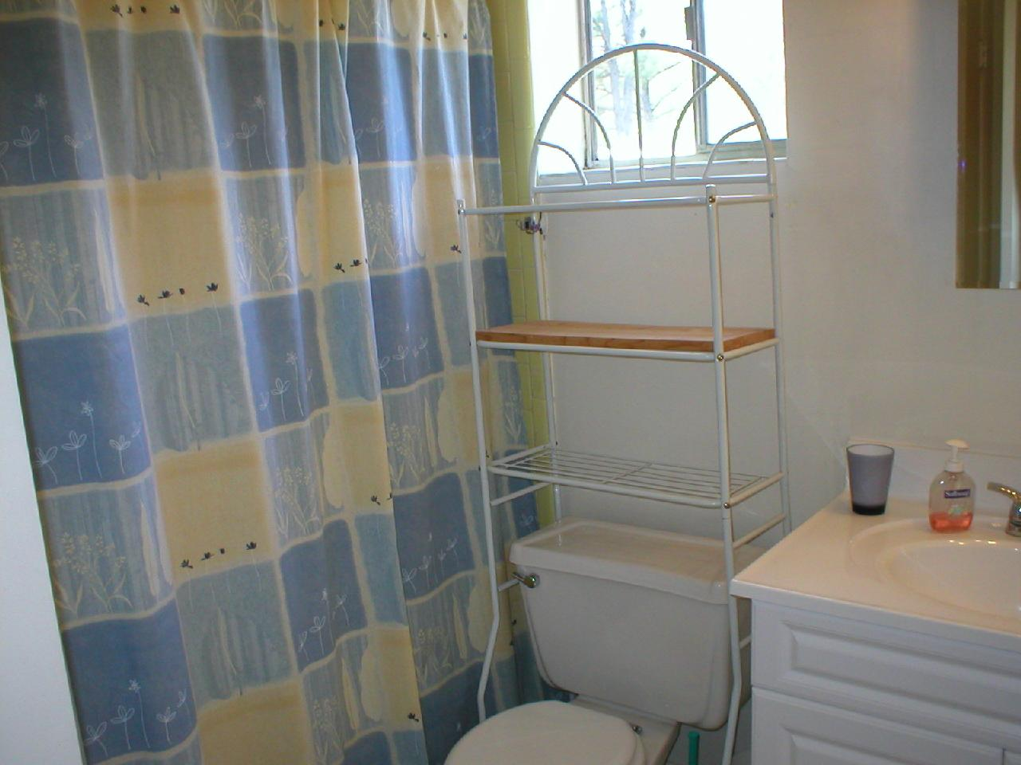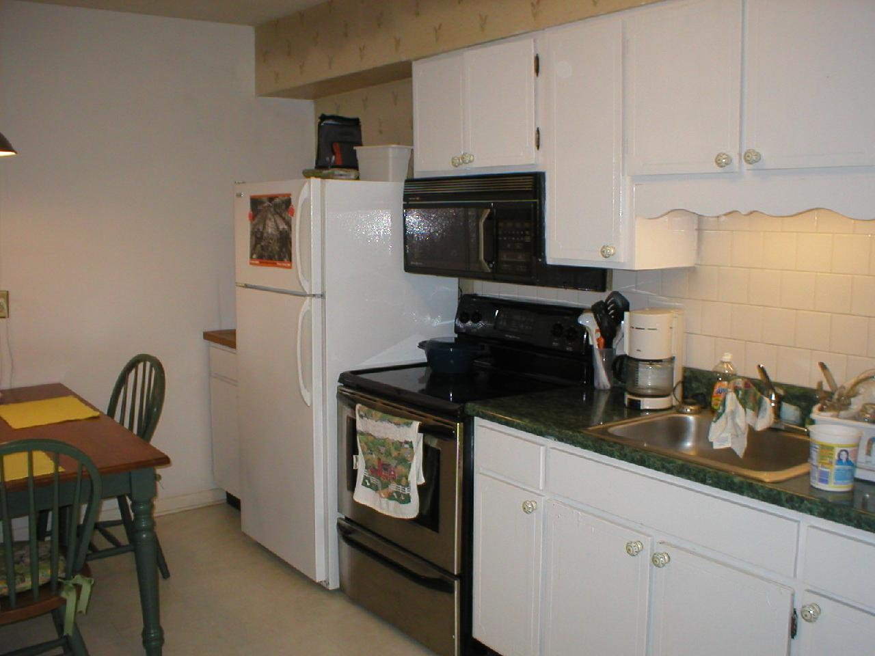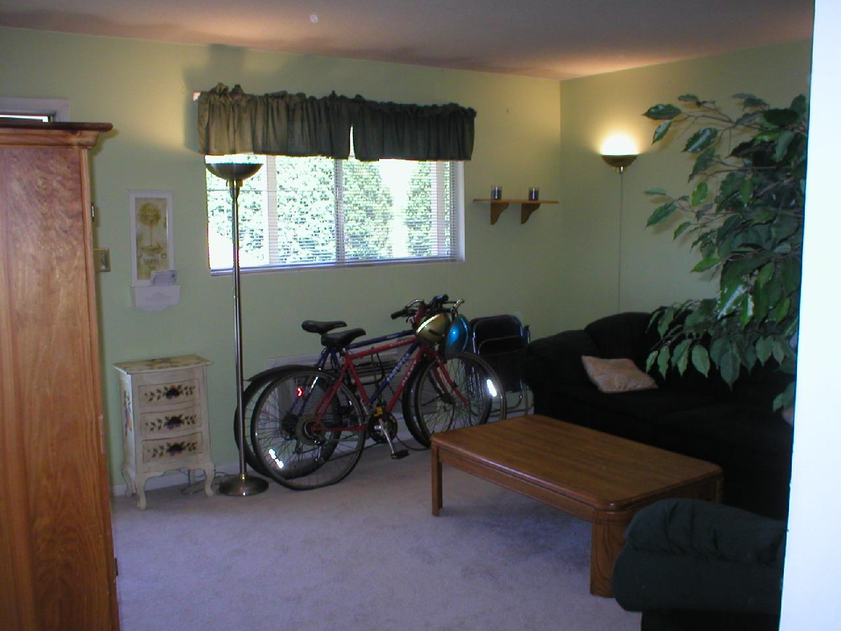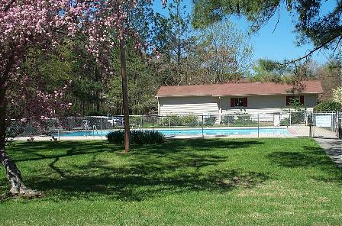

Share Townhouse, Walk to Campus, Furnished
Short Term OK
Home Away from Home, Only $350
205 Sunrise Ln, Chapel Hill, NC 27516
Property Information
Bedroom(s) | 4 | Year Built | 1970
Bath(s) | 2 | Square Feet | 1650
Neighborhood | Chalet | Garage | Off-street Parking
Elementary | Estes Hills | Junior | Phillips
High School | East Chapel Hill
Rent: | $350 | Availability: | now
Lease Term: | Month to Month or Longer | Application Fee: | - NA -
Contact: | Barbara Graham | 919-933-0650 | Barbara@allonebooks.com
Description: Walk, bike, or bus to campus. We have a room available in a solid townhouse now. Fully furnished with high-quality furniture -- a bed, desk, lamps, side table, and dresser, or unfurnished, your choice. There is shared access to the tastefully furnished kitchen, bath, living, and dining rooms. Full size washer/dryer, gas heat, central A/C. Your roommates will be 3 normal rather serious seniors (male & female). Less than one mile to Franklin & Columbia streets, bus is just down the hill, I-40 about 2 miles. Across from Foster's Market, Hunan Chinese, Flying Burrito, etc. Hardwoods and new plush carpeting. $350. Interested? 919-933-0650 or barbara@allonebooks.com

Amenities: Washer & Dryer. Refrigeration. Ceramic-top oven. Interior hardwoods, carpet and vinyl. Central A/C, Heat. Closet. Tastefully furnished with everything you will need for a comfortable stay:
-sofas, chairs
-desk
-armoire with TV
- twin bed
-dresser, side table
-plants
-fully equipped kitchen

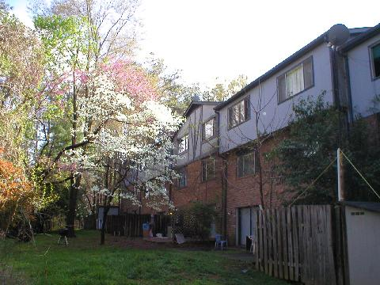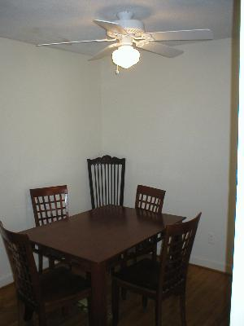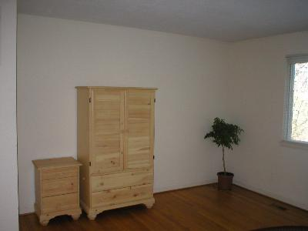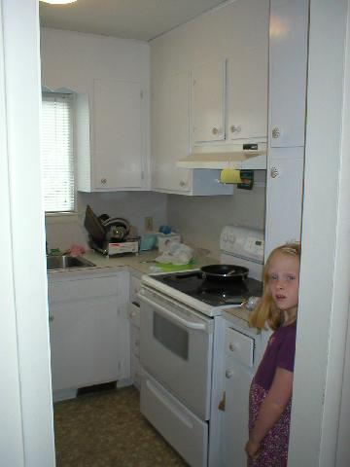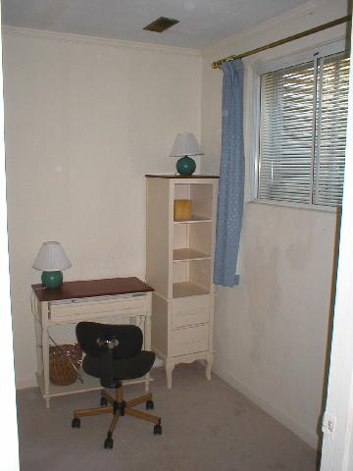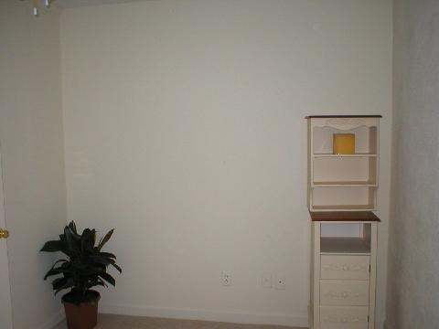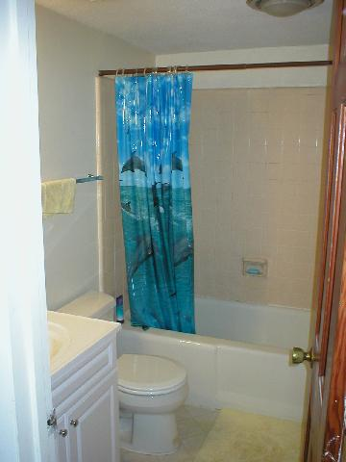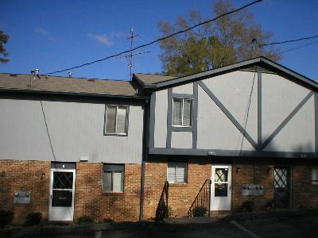

Only 7 Blocks to Campus
502 Edwards St, Chapel Hill, NC 27516
Property Information
Bedroom(s) | 3 | Year Built | 1962
Bath(s) | 1 | Square Feet | 900
Neighborhood | N/a | Garage | None
Elementary | Glenwood | Junior | Smith
High School | East Chapel Hill
Rent: | $885 | Availability: | 1 June 2004
Lease Term: | One Year Minimum | Application Fee: | - NA -
Contact: | Barbara Graham | 919-933-0650 | Barbara@allonebooks.com
Description: Walk, bike, or bus to campus. Newly renovated home will be complete June 1. Only 6 blocks to Franklin & Columbia streets, bus is just at the corner, I-40 about 2 miles. Hardwoods and plush carpeting. There will be construction in the basement for about 3 months to rectify water damage. Beautiful backyard overlooks Bolin Creek. Interested? Drive by then call 919-933-0650 or barbara@allonebooks.com (Rosemary to Mitchell to end, quick jog onto Edwards, 1st house on right.)

Amenities: Washer & Dryer. Refrigeration. Oven. Interior hardwoods, carpet and vinyl. Central A/C, Heat. Closets and fans in all bedrooms. Eat-in kitchen. Large living room.



