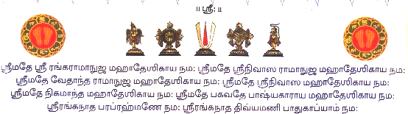
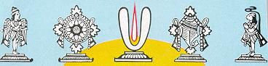
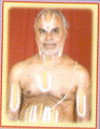
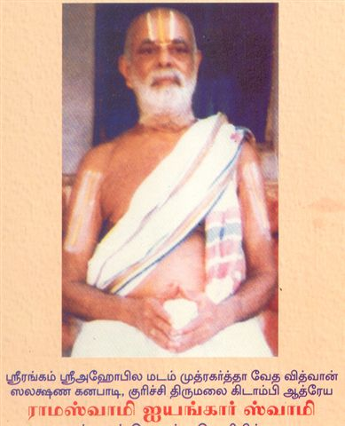
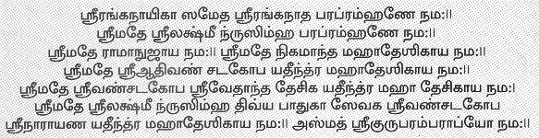
Sri U. Ve. Kuruchi Kidambi Athreya Lakshmi Narasimhachariar Swamy
Dear Bhaktas,
Sri U. Ve. Kuruchi Kidambi Athreya Lakshmi Narasimhachariar Swamy, son of Vedavidhwan, Salakshana Ganabadi Kuruchi Thirumalai Kidambi Athreya Sri Ramaswamy Iyengar Swamigal is devoting his retired life in teaching Vedas in Six Centres in and around Chennai. He has Re-published the following Prayoga Books Apasthamba Soothram (Yajur Vedam) in Tamil which was originally published by his Father.
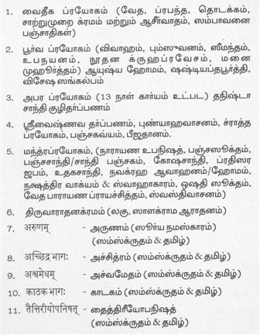
Vedha Prabhandha Thodakkam & Saathumurai, Sambaavanai & Aaseervada Panchathikal Cassette & CD (Audio Only)
Many Retired Brahmin’s are Learning Vedhas in all Centres. No Age Limit. Those who are interested to Learning Vedhas from the beginning and to buy the Books / CD / Cassette

Please contact.
“Ramajayam”
Old No. 38/2, New No. 89, K.R. Koil Street, West Mambalam, Chennai – 600 033
Ph: 044 24731265, Mob: +91 99403 85952

