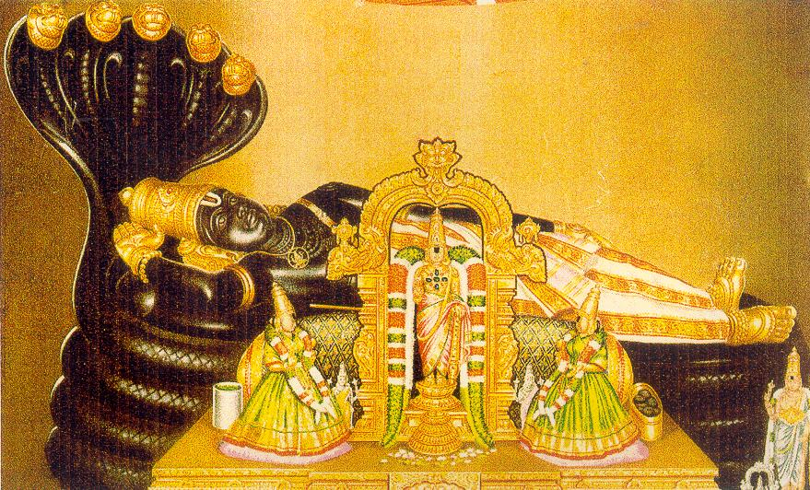 |  | 

Sri RanganAtha Temple
( Sri Ranganatha Seva Samithi Inc., )
( Regd. Non-Profit, Tax-Exempt, Religious Organization )
8-Ladentown Road, Pomona, NY-10970. USA.
Phone: 845-364-9790. www.ranganatha.org
Board Of Trustees:  Venkat Kanumalla  Chairman  John Laxmi  Vice-Chairman  Janakiramprasad Edara  Secretary  Murali Thyagarajan  Joint Secretary &  Cultural Committee Chairman  Hemwati Panhani  Treasurer  Bharathi Hodarkar  Joint Treasurer  Sadagopan Varadachari  Fund-Raising Committee Chairman  Dwarakanath Bangalore  Maintenance Committee Chairman  Murthy Ayyala  Religious CommitteeChairman  Arun Krishnmachari  Computerization Corrdinator  EXECUTIVE COMMITTEE :  President: Venkat Kanumalla  Secretary: John Laxmi  Treasurer: Krishna Kuchibhotla  Legal Advisor: Indra Pal  Religious Coordinator:  Srinivas Tanikella  Volunteers Coordinator:  Venkatesh Shenoy  Youth & Cultural Coordinator:  Chandra Kaluvakala | AshAdha Ekadasi – Sant TukArAm  Abhang Bhajans  Sunday, 07-29-2007  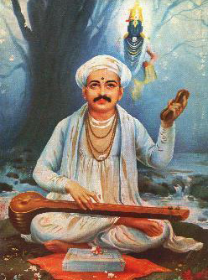  Programme:  8AM: Suprabhata Seva and Morning Worship.  10AM: Abhang Bhajans by Smt. Sumati Sarangapani  and Sri K.V. Narayanan  11AM: Sri Srinivasa Thirukalyanam  1PM: Prasadam distribution.  6PM: Sri Satya-NarAyaNa Pooja – AshAdha Pournami.  Sponsoring any and all events at Sri RanganAtha  Temple is our BhAgyam.

