
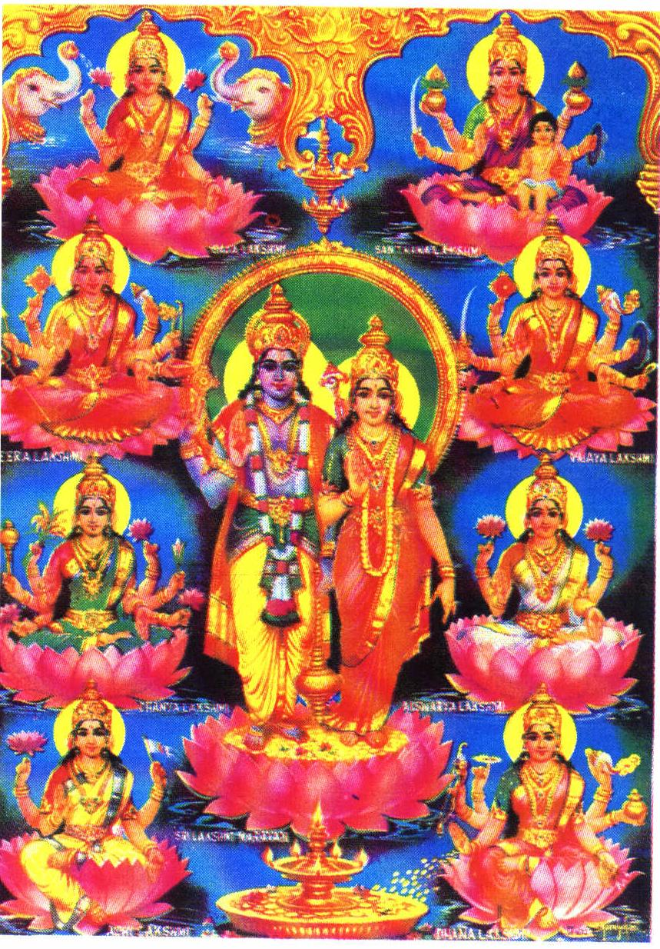

§
(Sri LakshmiNarayan)

Jai Srimannarayana! Jai Srimannarayana! Jai Srimannarayana! Jai ! Jai! Jai!

AshtaLakshmi Temple
BRINGS
3 GRAND EVENTS
Sri Vishnu Puran
by HH Swamiji
Ground Breaking
& Sree Yagam
Sri Sudharsana
Havan
Sunday, June 27’th
9.00 A.M - Noon
July 10’th, 11’th & 12’th

Sunday, July 11’th
9.00 A.M - Noon
FIRST TIME IN HOUSTON
Sri Sudharsana Jayanthi is on June 27’th. Sri Sudharsana, the Holy Discus of Sriman Narayana, destroys all evil forces, protects devotees and leads them to serve the Lord. Sriman Sudharsana Venkatesh Iyangar SwamiJi will be performing Sri Sudharsana Havan.

Sri Tridandi Srimannarayana Ramanuja Chinna Jeeyar SwamiJi will be gracing Houston from July 10’th to 12’th. On the occasion of AshtaLakshmi Temple’s Ground Breaking Ceremony, SwamiJi will be performing Sree Yagam. Sree Yagam is performed to grace Goddess Lakshmi – Goddess of Wealth. All devotes are cordially invited to join, support the event & receive the blessings.
LOCATION: Sudarsana Havan & Sree Yagam will be conducted ON SITE, adjacent to Swami Narayan Temple on 10008 SYNOTT, between West Belfort & Bissonet.
. Prasad is Served . Admission is FREE . Donations are Welcome . Air Conditioned Tent

$101 – SPONSOR - Priest will perform the havan on behalf of the devotee
$31 – ANUUAL MEMBER$500 – DONOR$2,500 – GRAND PATRON
$250 – LIFE MEMBER$1,000 – PATRON $5,000 – BENEFACTOR
$10,001 & more – GRAND BENEFACTOR (before July 11’th, 2004) – The devotee will be contributing a foundation stone towards the Ground Breaking.
Any Contribution would help towards the Construction of the Temple.
During SwamiJi’s visit, His Holiness will be offering discourses in ENGLISH on Vishnu Puran. Time & Location to be announced.
“Serve All Beings as Service to God”
“Worship Your Own, Respect All”
-- HH Chinna Jeeyar SwamiJi

WE CORDIALLY INVITE ALL DEVOTEES TO JOIN, PARTICIPATE & SUPPORT THE EVENTS
Jai Srimannarayana! Jai Srimannarayana! Jai Srimannarayana! Jai! Jai! Jai!
For more details, please visit our web site www.ashtalakshmi.org
Email: contact@ashtalakshmi.org
Contact Us:
Anand & Apoorva Srinivasan: 281-291-7376 (H) Anjaneyulu & Kumari Koneru: 713-466-5623 (H)
Drs. Chary & Renu Tamerisa: 281.242.9660 (H) Manohar & Geetha Donthi: 281.808.2159 (C)
Padmakanth & Rama Kambhati: 281-879-6395 (H) Rajan & Seetha Madabhushi: 281.437.2735 (H)

Discourses in English

