http://www.avatara.org/dhanvantari/sorta.html
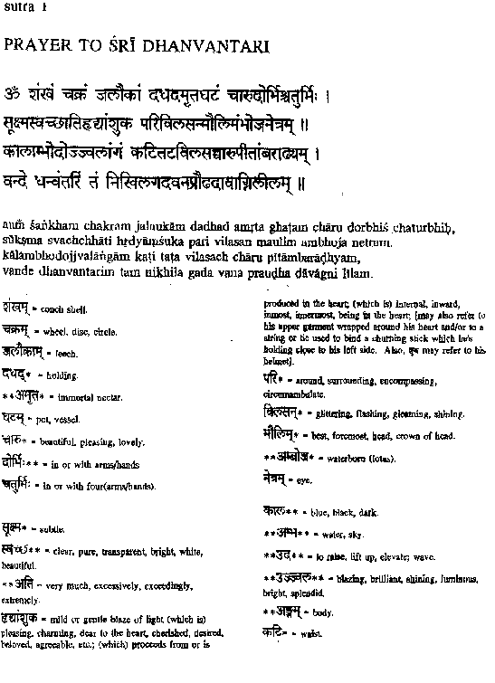
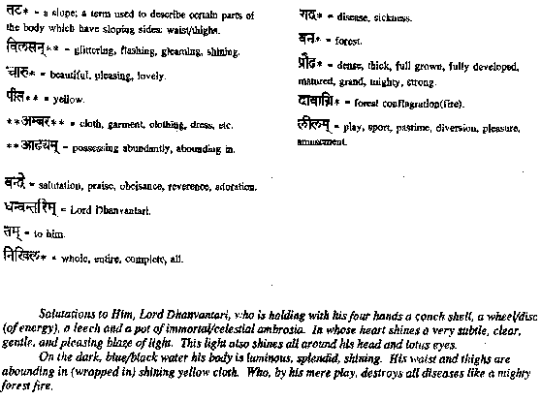

The avatara of Dhanvantari appeared billions of years ago. Although an avatara is unborn, He takes His divine birth among the living beings to display His divine pastimes.
The First Appearrance of Dhanvantari
In this epoch (kalpa), He first appeared during the great churning of the cosmic milk ocean to deliver amrta (nectar) for the nourishment of the demigods. The churning of the milk ocean is one of the most famous episodes in Puranic history and is celebrated in major way every twelve years in the festival known as Kumbha Mela. The story is related in the Srimad Bhagavatam, a major work that describes the avataras in great detail. Here is what happened:
The great leader of the demigods Indra was riding on his elephant, when he came across Durvasa Muni. Seeing the great demigod, Durvasa offered him a special garland (mala). Indra accepted this garland and put it on the trunk of the elephant. The elephant threw the garland onto the floor, thus enraging Durvasa Muni. In a fit of anger, the sage explained that the garland was the dwelling of Sri (fortune) and was therefore to be treated as prasada. (1) Therefore cursed Indra and all the demigods to be bereft of all strength, energy, and fortune (Sri).
In the ensuing battles, the demigods were defeated in battle and the demons headed by Bali gained control of the universe. The demigods sought out the help of Lord Vishnu, who instructed them in the art of diplomacy. The demigods then entered into an alliance with the demons to jointly churn the ocean for the nectar of immortality and to share it among them. Of course, the demigods were told by Vishnu that He would arrange for them alone to obtain the nectar, which would empower them to defeat the demons.
All kinds of herbs were cast into the milk ocean and using Mandara mountain as the churning rod and Vasuki as the cord, they proceeded to churn the ocean. This churning was so arduous that Lord Vishnu Himself interceded in so many ways to aid the demigods: He was present as Lord Ajita pulling on the side of the gods, as Lord Kurma who supported the great Mandara mountain which was in danger of sinking, and Lord Vishnu Himself sat atop the Mountain infusing the demigods and the serpent Vasuki with energy. Many great beings and objects were produced from the ocean and were accepted by various demigods as offerings. Laksmi-devi, the goddess of fortune, appeared from the ocean and Vishnu and Her were reunited as husband and wife after having been separated for many ages.
Then as they continued churning, a very wonderful male person appeared. The Bhagavatam tells us, "He was strongly built; His arms were very long, stout and strong; His eyes were reddish, and His complexion was black. He was very young, He was garlanded with flowers, and His entire body was fully decorated with various ornaments." (2)
Lord Dhanvantari was "dressed in yellow garments and wore brightly polished earrings made of pearl. The tips of His hair were anointed with oil and His chest was very broad. His body had all good features, and He was stout and strong as a lion. In His hand, He carried a jug of nectar."
The demons stole the jug of nectar and Lord Vishnu appeared as Mohini, a beautiful woman, who fascinated the demons and recovered the nectar from them. The demigods took the nectar and drank it and were invigorated with energy. Thereafter, the demigods fought the demons and were victorious. They greatly rejoiced and worshipped Lord Vishnu and Lakshmi, the goddess of fortune, and resumed their position in the heavens.
Dhanvantari's Second Appearance (3)
The second appearance occurred at the beginning of the reign of the current Manu in the second Dvapara-yuga, two billion years ago. Lord Vishnu foretold at the time of the churning that Dhanvantari would appear again in the human society and be offered sacrifices and worshipped by human beings. He would also teach them the science of Ayurveda. Dhanvantari at that time was residing in the heavens and Lord Indra seeing the misery of human beings afflicted by disease on earth, requested the Lord to teach Ayurveda to the human race.
At the same time, the King Dirghatamas of Kasi was performing penance, desiring a son. The king desired to propitiate Lord Dhanvantari for the sake of a son. Thereupon, Dhanvantari appeared to him and urged the king to choose a boon as he pleased. The king said, "O Lord, if You are pleased with me, be my son, bestower of my goal." The Lord replied, "So be it," and He vanished.
Lord Dhanvantari was then born in the royal household of Kasi. He developed ascetic tendencies even as a young boy and performed severe austerities. Lord Brahmawith great difficulty persuaded Him to accept lordship over the city of Kasi and since then He bacame known as Kasi-raja. As a king He prepared the samhitas on Ayurveda in eight divisions for the benefit of humanity.
Lord Dhanvantari's teachings are recorded in the Agni Purana 279-289 as well as through the teachings of His disciple Susrutha.
The Bhagavatam states "smrta-matrarti-nasanah" One who remembers the name of Dhanvantari can be released from all disease.
A final note:
Those who are new to Vaishnava and Puranic thought may wonder at the purpose of the Lord's array of avatars especially during the churning of the milk ocean. After all if God is all powerful, why couldn't He accomplish all His ends at once? Why does He have to act through so many different forms? In answer to this, the Vedic literature affirms the omnipotence of the Lord in His various avatars. However, when the Lord descends, He Lord seamlessly fuses His serious purpose (in protecting the demigods and humanity) with sheer sport. In the form of Mohini, He enchants the demons and the demigods. As Lord Dhanvantari, He diminishes the misery of the world by teaching the medical sciences. As Lord Ajita, He enjoys assisting His devotees directly in their struggle for victory. At times He even desires His devotees to be glorified, which is why Lord Shiva drank the poison produced of the ocean. The poison turned his neck dark-blue, hence the name Nila-kantha. In short, although the devotees never stop glorifying the Lord, no one can fully understand His divine play (lila).
(1) Visnu Purana 3.10.12
(2) Srimad Bhagavatam 8.8.32
(3) The story of the second appearance is told with details in the Brahmanda-purana (2.3.67.10-24) and Bhava-prakasa (purva-khanda, 1) a minor Ayurvedic text

