 |  |   1600 Las Virgenes Canyon Rd, Calabasas, CA -91302  Web site: www.hindutemplemalibu.com. |  | 
Sri
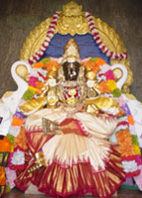 | 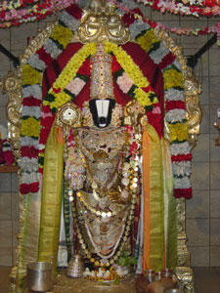 | 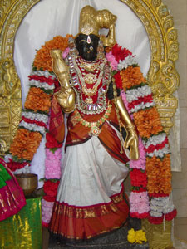

Sri Alarmelu manga samedha Sri Srinivasa Prabrahmane namaha
Sri Ramanujaya namaha
Sri Nigamaantha Maha Desikaya namaha
Sri Vara Varamuniya namaha

Sri Ramanuja Jayanthi
On Friday, Saturday and Sunday, April 20th - 22nd 2007.

Hindu Temple Society of Southern California is pleased to announce the celebration of Sri Ramanuja Jayanthi with the consecration of :

- All the 12 Alwars &

- Aacharyas
    - Sri Ramanujar
    - Swamy Sri Desikan
    - Sri Manavaala Mamuni

at the temple. All are cordially invited. Please join us on this joy and gracious occasion and seek their divine blessings.

Sri

Program schedule :-

Friday, April 20 2007 (Evening) - Bhagavath Anugraham
Punyaavachanam
Mruthungraganam
Anguraarpanam
Aacharya Rakshabhandhanam
Vedha Vinnappam
Vaasthu Santhi
Thiruvedhi Agni Pradhishtai
Kumbasthapanam (Kumba Prathistai)
Utha Homam
Poornaahudhi
Saatrumurai

X========================================X

Saturday, April 21 2007 (Morning) - (Before Thirumanjanam)
Punniyavaachanam
Agni Pranayanam
Kumbaaradhanam
Uttha Homam (Adhi vaasa Homam)
Nathronminnam
Pancha Kavyaadhi vaasam
Sheeradhi vaasam
Jaladhi Vaasam
Poornaahudhi
Saatrumurai

(Both Prabhandham and Upanishad will go in Parallel. But exactly at 10.00 Perumal Thirumanjanam will be started, as usual.and the program goes till Saatrumurai

(Evening) - Puniyaavaachanam
Maha Shanthi Homangal
Periya Thirumanjanam
Bimba Vaasthu Santhi
Bhimba Raksha Bhandhanam
Seyanaadhi Vaasana Homangal
Avuthira Prasamsam
Utthira Homam
Poornaahudhi
Saatrumurai
X========================================X

Sunday, April 22 2007 (Morning) - Puniyaavaachanam
Kumbaaraadhanam
Agni Pranayananm
Utha Homam
Maha Poornaahudhi
Yathira dhanam
Kumbam – Bhimam Purapaadhu
Bhimam Prathishai
Kumba Prokshanam (Samrokshanam)
Maha Nivedhyam
Mantra Pushpam
Periya Saatrumurai
Magadhaaseervadham
Aacharya Bahumaanam
Uthsavam
Prasadham Distribution.

THE END

