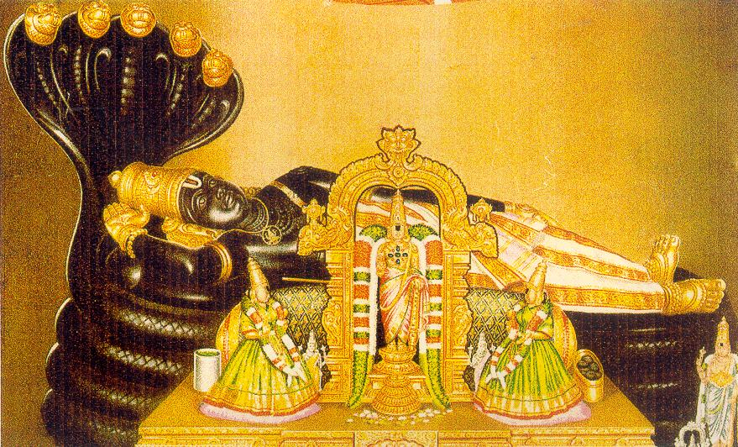 | 

Sri RanganAtha Temple
Sri Ranganatha Seva Samithi, Inc.
(Regd. Non-Profit, Tax Exempt, Religious Organization)

8 Ladentown Road, Pomona, NY-10970 (Phone: 845-364-9790)
www.ranganatha.org

Indra Pal: 718-875-3334
Legal Advisor

John Laxmi: 646-812-8949
Accounting Advisor

Srinivas Tanikella:
201-343-4595
Religious Committee Member

Board of Trustees

Venkat Kanumalla
Chairman: 845-627-6716

Ramu Surapaneni:
Vice-Chairman: 845-639-6977

Janakiram Prasad Edara
Secretary: 845-323-4108

Gurunath Pagala:
Joint Secretary: 845-268-4942

Hemwati Panhani
Treasurer: 718-740-4332

Bharathi Hodarkar
Joint Treasurer: 845-354-6202

Murthy Ayyala:
631-689-8927: Religious Committee Chairman

Dwarakanath Bangalore:
845- 638-4220: Maintenance Committee Chairman.

Trimbak Bharati:
845-623-0345 : Fund-Raising Committee Chairman.

Radhika Murali:
201-666-0345: Cultural Committee Chairman

Sampath Rengarajan:
734-332-1272
On behalf of our GREAT MahadAchAryas, Sri NigamAnta-MahA-Desika, the First, the 44th and the present 45th Pattam Srimat Azghagiyasingars, the Devotes, Volunteers & the Board of Trustees invite you all to come and participate in
Bhagavad Sri RAmAnujAchArya’s Tirunakshatram ( Birthday - Chaitra Ardra )
 | Yo nityam  Achytha padAmbuja  yugma rukma vyAmOhatha:  thadhitharANi thruNAyamene -asmad gurO: bhagavathosya dhayaika sinDhO: rAmAnujasya charaNau  SaraNam  prapadye
with all your family & friends on Sunday, April 22, 2007
and receive the blessings of the Mahadaacharya and the
Divya Dampatis– Lord Sri RanganAtha and Sri MahA Lakshmi.
Program:
8 AM : SuprabhAtam, NityAnusandhAnam, Morning Worship.
10 AM: Thirumanjanam ( Abhishekam ) to Bhagavad Sri RAmAnujAchArya ( Moolavar & Utsavar ) followed by Bhagavad RAmAnuja nUtranthAdhi and Gadya-Traya Parayanam, AchArya Maryada, AchArya SambhAvana
12 noon: Sri SrinivAsa KalyANam & Prasadam Distribution.
Sponsoring any & all events at Sri RanganAtha Temple is our BhAgyam
( Sponsoring Abhishekam, Archana & KalyAnOtsavam – YathA-Sakthi )

