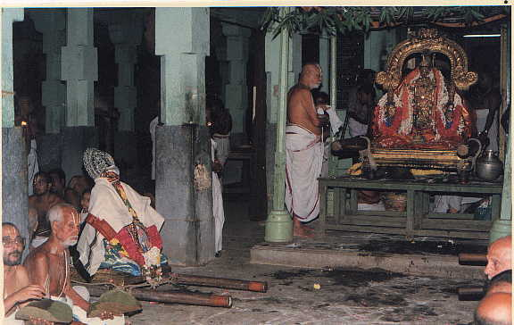
Anushtanakula Usthavan - Congregation of Three
The lord (Pravartaka) Sribashyakara (siddanathastapaka) and swami Desikan (samrakshaka) are assembled here.

