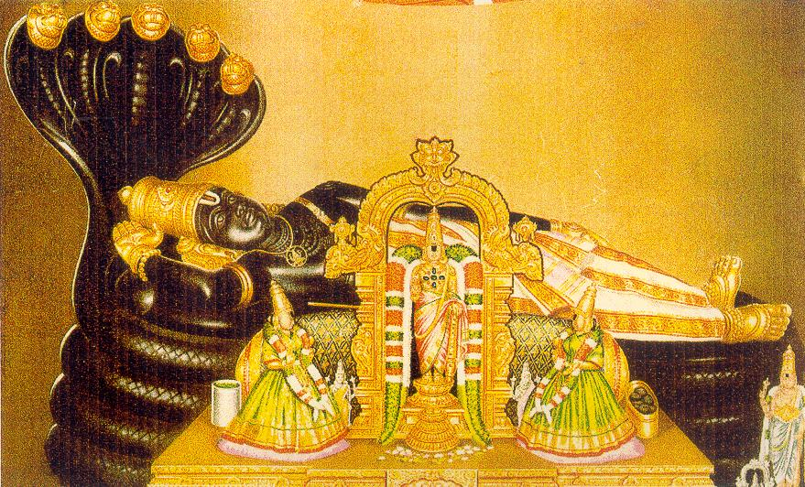 |  | 

Sri RanganAtha Temple
( Sri Ranganatha Seva Samithi Inc., )
( Regd. Non-Profit, Tax-Exempt, Religious Organization )
8-Ladentown Road, Pomona, NY-10970. USA.
Phone: 845-364-9790. www.ranganatha.org
Board Of Trustees:  Venkat Kanumalla  Chairman  John Laxmi  Vice-Chairman & Treasurer  Janakiramprasad Edara  Secretary  Murali Thyagarajan  Joint Secretary &  Cultural Committee Chairman  Bharathi Hodarkar  Joint Treasurer  Sadagopan Varadachari  Fund-Raising Committee Chairman  Dwarakanath Bangalore  Maintenance Committee Chairman  Murthy Ayyala  Religious CommitteeChairman  Arun Krishnmachari  Computerization Corrdinator  Hemwati Panhani  EXECUTIVE COMMITTEE :  President: Venkat Kanumalla  Secretary: John Laxmi  Treasurer: Krishna Kuchibhotla  Legal Advisor: Indra Pal  Religious Coordinator:  Srinivas Tanikella  Volunteers Coordinator:  Venkatesh Shenoy  Youth & Cultural Coordinator:  Chandra Kaluvakala | On behalf of our Great AchAryas, Bhagavat RAmAnuja, Sri  NigamAnta -MahA-Desika, the 1st and the present 45th Pattam  Srimat Azghagiyasingars, the Devotees, Volunteers, Board of  Trustees and the Executive Committee Members invite you all  to attend the Tirunakshatram of our Temple Founder-AchArya,  the 44th Jeer of Sri Ahobila Mutt, on Thursday, 9-13-2007 & also  the Special Celebrations on Saturday, 9-15-2007 and receive the  blessings of Srimad Azhagiyasingar & the Divya-Dampatis-  Sri MahA Lakshmi & Lord Sri RanganAtha.  AchArya Taniyan:  sri ranganAtha sathagOpa yatIndhra dhrashtum  Lakshmi-Nrusimha saThajit karuNaika pAtram  Sri ranga veera raghurAt saThagOpa hrudhyam  VedAnta dhesika yatindram aham prapadye.  PROGRAMME: 9-13-07 Abhishekam to 44th Jeer at 10 AM.  9-15-07: 10 AM: Special Abhishekam to 44th Jeer along with Lord  Sri Lakshmi-Nrusimha’s SwAti Tirumanjanam with 9 Kalasams  11.30 AM: pArAyaNam of 44th Jeer’s Compositions.  12 Noon: Special Purappadu Utsavam for 44th Jeer and visesha  maryada at all sannidhis followed by delicious Prasadam.  Sponsoring any & all events at Sri Ranganatha Temple is  Our bhAgyam.
  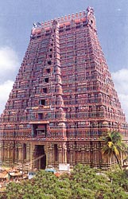 | 