- Start truespace3: if there are any objects present at this time, hold the left mouse button over “file”, then select “scene” and finally “new” to clear the work space.
- First change the view top view. By holding on blue arrow and dragging up to red arrow.
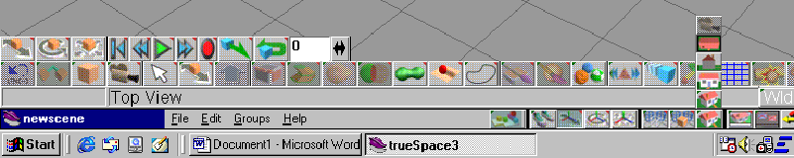
- Next make a new front view screen. To do this drag to the new perspective view and drag up to new front view. It is indicated by the orange arrow above.
- To begin the piece you will need to make the base. To do this begin by creating a cylinder by the primitive panel. (Black arrow above). Then drag up to cylinder and release.
- Use the front view window to look at the cylinder, then take the scale button and scale it down so it looks flat and is still a circle. 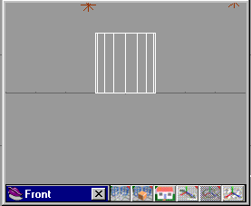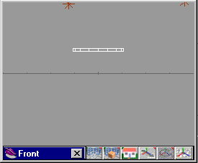
- Now we will create the mid section of the pawn. To do so we will be using the lathe tool. First select the polygon tool: 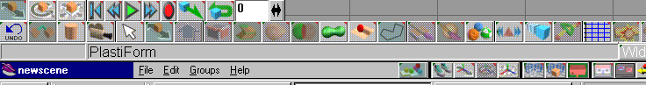
- Then in the top view screen create half of the mid-section by using short fast clicks to create the curves. It should look something like this:
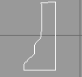

8.Then select the lathe tool on the primitives panel:
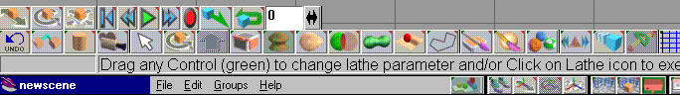
- When selected right click on the lathe tool and bring up the menu and set it up as follows:
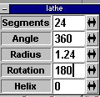

- Align the lathe tool with the midsection of the pawn as follows:
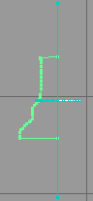
- Then click the lathe tool and it should be complete now:
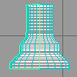

- Now we will create the neck piece. To do so you must first start with a sphere. Once you have the sphere you then scale it down so it is flat like so: ( make sure to use both views so that it is flat in the front view and still round in the top view.) 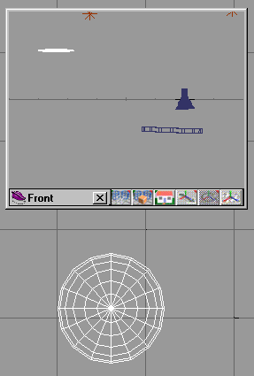
- Then we will need the final piece, the top. All you need for that is a sphere.
- Next you will need to line up all the pieces to do so right click on the arrow button so that the chart comes up ant set all the locations of all the parts the same.( keep highlighting a piece and changing the location until they are all the same). 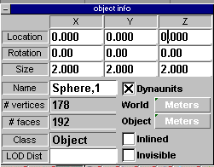
- Then go through all the pieces and scale them so they are proportionate as they would look on a real pawn, and move them to there location on the piece.
- Once everything is in line then you select the base of the pawn, then select the glue as child tool (Next to undo) and glue all the pieces together making the pawn one complete piece. It should look something like this: 